
www.dovecomequando.net

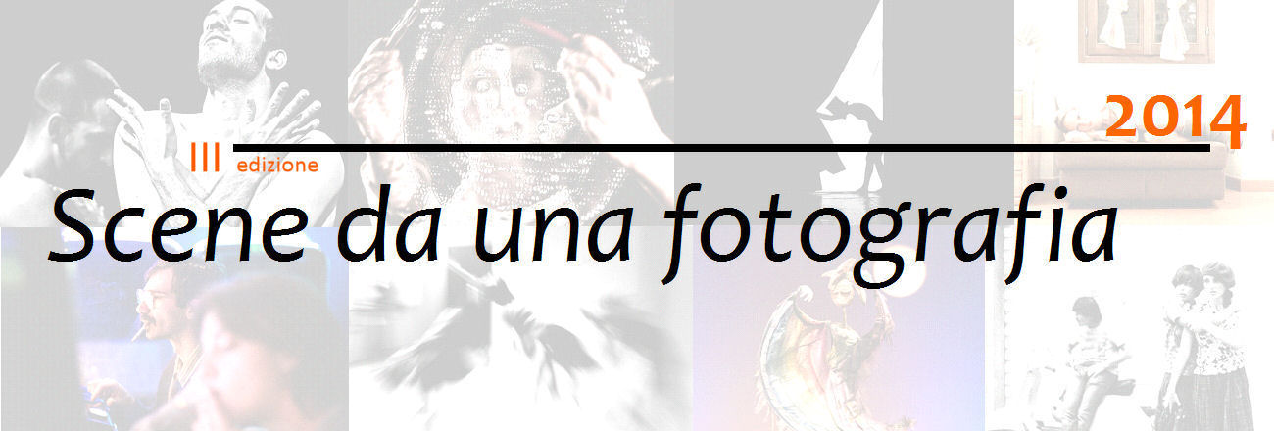
photos by: Stefania Casellato, Simone Cecchi, Francesca Falsetti, Simona Fossi, Daniela Neri, Antonella Pandini, Luca Rossini

INTRODUCTION

Within the IV edition of the INVENTARIA ²⁰¹⁴ Theatre Festival, the Italian based DoveComeQuando theatre company (DCQ) promotes "Scene da una fotografia", (Scenes from a Picture), a photography contest aiming to bring to light and develop those photo projects (stage pictures, stage portraits, backstage pictures, etc.) marked by a personal approach to the notion of theatre itself, which every artist brings with himself/herself.

No specific theme is provided for the 2014 edition.

TERMS

1. ELIGIBILITY

The contest is open to every artist of any nationality, with the exclusion of the members of DCQ and of the photographers who have already worked with DCQ.

2. ENTRIES

In order to enter the contest, you have to send an email with attached either a .zip or a .rar compressed file (6 MB max), containing a photographic project consisting of min. 5, max 20 pictures (.jpeg format, 72 dpi, min 800 pixels on shortest side). Each picture must be renamed after the author and the intended order of vision (e.g. Smith_01).
Emails must be sent to scenedaunafotografia@dovecomequando.net.

In order to be eligible for the finals, the authors must be able to provide high resolution versions of the same pictures.

To the same email, every participant must also attach:
a) the compiled and signed entry form;
b) a brief introduction to his/her project stressing its pertinence with the theme;
c) a proof of payment for the entry fee (see n. 3 below)
d) either a curriculum vitae or a brief bio are welcome, but not mandatory.

Emails must be sent by April 8th 2014, 11:59 PM (CET).

More than one project can be submitted, provided the equivalent amount in entry fees is paid.

3. PAYING THE FEE

The amount of the entry fee is 8 €. You can pay:

1) either by bank transfer to the following bank account

name: Associazione DoveComeQuando
at: Banca di Credito Cooperativo di Roma
IBAN: IT53M 08327 03221 000 000 003593
BIC (SWIFT): ROMAITRR (for international bank transfers)
object: [name surname, project title]

or

2) by transfer to Postepay* no. 4023 6006 2373 3203 owned by Pietro Dattola (treasurer of DoveComeQuando). In such a case, in order to correctly match the payment with the participant, he/she will have to:
either scan or save the receipt and attach it to the email;
or insert in the body of the email the following data: name and surname of the participant, name and surname of the stored-value card owner (if different), date and time of the payment.

* Postepay is an Italian stored-value/pre-paid card.

4. THE JURY

The jury (see also below, at the end of this document) is composed of:
- Lorenzo Cascelli (editor of the Atelier section of the registered online newspaper Pensieri di Cartapesta);
- Riccardo De Antonis (photographer, professor at the Quasar Design University Institute in Rome);
- Laura Toro (contest manger and founding member of DoveComeQuando);
- Lorenzo Torreggiani (director of Clic-hé - webmagazine di fotografia e realtà visuale).

The jury's verdicts are final.

5. SCREENING AND PRIZES

A number of selected projects will enter the final phase. The finalist projects will be fully published online on www.dovecomequando.net and on the arts portal of the registered online newspaper Pensieri di Cartapesta's, www.pensieridicartapesta.it.

Each finalist will have to choose a selection of 5 photos from his/her project. These will be displayed at the foyer of the Teatro dell’Orologio for the whole duration of the IV edition of the INVENTARIA ²⁰¹⁴ Theatre Festival (May 12th-25th 2014).
The finalist will have to send the high resolution version of the selected photos according to the guidelines to be provided by DoveComeQuando; the pictures will be printed and mounted in the 20x30 format by “Irfe Colore”, at the price of € 8,00 (including VAT) each.

Failing to send the files and/or pay the print costs will result in automatically forfeiting the contest. The prints will be taken and arranged for display at the theatre by DCQ representatives.
Once the Festival is over, the finalists can ask for their prints to be sent to them at their own expense.

The winner will be announced on May 25th 2013, at the end of the final evening of the IV edition of the INVENTARIA ²⁰¹⁴ Theatre Festival.

Prizes include:
- public display from 5th to 11th June 2014 at White Wall of the highly regarded Ashanti Gallery, in Via del Boschetto, 117 – 00184 Rome of a selection of photos of the winning project; the exact number of photos to be displayed, between 5 and 15, will be decided by the Gallery;
- public display from 12th to 22nd of June of up to 15 selected photos of the winning project at the prestigious Quasar Design University Institute, via Nizza 152 - 00198 Rome;
- free printing of up to 10 more photos of the winning project (those that are to be displayed at the Quasar Design University Institute beside the previously selected 5).
- full display of the winning project & another project by the same author on the arts portal www.pensieridicartapesta.it. The winning project will also be published on the photography webmagazine www.clic-he.it. A selection of the winning project will also be displayed on the web magazine www.fourzine.it and on the Quasar Design University Institute website, www.istitutoquasar.com, while the author will be interviewed by the portal www.chiediteatro.com.

6. USAGE, (COPY)RIGHTS AND LIABILITIES

For all ends and purposes, the copyright to the pictures are their own author's or their due holder's. For third parties to use the pictures, the copyright holder's authorization will be required at all times.

The files sent by the winner and the finalists of the contest will be included in the online picture archive of DoveComeQuando. By entering the contest, the winner and the finalists authorize DoveComeQuando to use their pictures - with all due credit - in relation to DoveComeQuando activities and initiatives; all the other participants authorize DoveComeQuando to use their pictures - with all due credit - in relation to this contest (for this and future editions) and its promotion.

The digital images will be stored for the duration of the contest. Once the contest ends, a back-up copy will be made, and no further usage will be made of the pictures other than those expressly mentioned in this document.

DoveComeQuando is committed to complying the Italian applicable privacy laws and regulations.
The participants release DoveComeQuando from any liability whatsoever concerning third parties rights to the pictures (for example, but not limited to, whether the images can be published).

7. MISCELLANEOUS

Should an issue arise which is not covered by this document, it will be decided upon by the jury.
By entering the contest, you fully accept the terms stated above.

8. CONTACTS

www.dovecomequando.net
scenedaunafotografia@dovecomequando.net
+39 320-11.85.789, +39 32906.53.524

You can also download this document from www.dovecomequando.net/scenedafoto14.htm

Rome, February 5th 2014 Signed

Contest manager: Laura Toro
DoveComeQuando president and treasurer: Pietro Dattola

DoveComeQuando expresses its gratitude to the following partners for their support to the contest:





THE JURY

Lorenzo Cascelli

Lorenzo Cascelli got a Philosophy degree in 2012, in Esthetics with a thesis on The tree of Life by T. Malick and Melancholia by L. von Trier. Editor in Chief of the Cinema section of the online magazine “Pensieri di Catapesta”, he is one of the organizers of the training program "Testimony and history in cinema" (October 2011 May 2012), related to the chair of Aesthetics in the FILESUSO faculty of La Sapienza University of Rome and the training W.I.P. in collaboration with Teatri di Vetro (March-May2013).

Riccardo De Antonis

He began to deal with professional photography in the early 70s, attending, in the meantime, the Institute of History of Art of La Sapienza University - in particular the courses regarding the History of Theatre. From 1977 to 1997 he was assigned the task of photographically documenting the demoanthropological assets of the National Museum of Arts and Popular Traditions, specializing in photojournalism and anthropology campaigns for photographic catalogs, exhibitions, and books of art history with major publishers. Between 1978 and 1985 he photographed the contemporary theater scene in Rome and Milan, covering about 400 shows; part of this work was selected and displayed in Rome in 1984 at the Sala Barbo of Palazzo Venezia, and then again in 2003, this time thanks to the Library Museum of Actors in Genoa. Since 1996 he has been teaching photography at the Quasar Design University Institute in Rome for the courses in Digital Photography, Graphics and Visual Communication, Habitat Design, Web&Interaction, Virtual Architecture, and Hypergraphics.

Laura Toro

One of the founding members of DCQ, she holds a master's degree in Economics and Enhancement of Cultural Institutions. She has collaborated with with Formez for the "Cultural heritage for local development" sector. She has studied stage photography with Laura Arlotti, and she is responsible for the stage photos of DoveComeQuando dramas and Inventaria Festival. She is the manager of the photo contest Scenes from a picture since its first edition.

Lorenzo Torreggiani

Free lance journalist, he is the Editor in Chief of “Clic-hé - webmagazine di fotografia e realtà visuale" and contributes to several magazines, such as “Sherwood – Foreste ed Alberi Oggi” and “Top Life Magazine”. He is interested in writing, photography and mountain. He manages the blog “Scrivere & Fotografare”, a space for reflection through images and words, and he collaborates with the Association Deaphoto.

“Scene da una fotografia”
(Scenes from a picture)

III Edizione / III Edition

SCHEDA DI ISCRIZIONE / ENTRY FORM

Nome/First name _______________________ Cognome/Surname ____________________________

Luogo e data di nascita/Place and date of birth: ______________________________________________

Indirizzo/Address _____________________________________________________________________

Città/City _______________________________ C.A.P./Post Code _____________________________

Stato/Country _______________________________ Nazionalità/Nationality _____________________

Tel. _______________________________ Email __________________________________________

Titolo del progetto/Project Title ___________________________________________________

Anno e data di realizzazione/Project Year and Date ___________________________________

Numero fotografie inviate/Number of photos ________________________________________

Come avete saputo del concorso?/Where did you find out about this contest?

___________________________________________________________________________________

Dichiaro di conoscere ed accettare integralmente il regolamento del premio. / I know and accept all of the terms of the contest.

Luogo e data / Place and Date Firma / Signature

In relazione alla normativa di cui al Decreto Legislativo 196/03 sulla privacy, il partecipante acconsente al trattamento, diffusione e comunicazione dei dati personali richiesti. / I authorize DoveComeQuando to manage my data as per Decreto Legislativo 196/03.

Luogo e data / Place and Date Firma / Signature

